***Shadow of Mordor*** ***The board game***

Introduction:

This week the team had to come up with an idea of a digital game and implement it into a physical (board for example) game. The game that the team decided to implement from digital to physical was Shadow of Mordor.

Game Premise:

The game that the team created involved territorial acquisition and battles among the players on the board.

Rules:

Maximum number of players is 4

Players start from their own castle with 1 captain orc and 5 follower orcs.

Players roll a six-number dice to see who goes first (highest goes first, lowest goes last).

Players roll a dice to see how many spaces they move.

Players can go in any direction.

Players can gain territories when they move to a space that has not been taken by another player

Player can get cards by acquiring territories

Player get bonuses by having more and different cards

These bonuses can include Morale Boost which make the orcs do 50% more damage or Extra turn which provides an extra turn to the player if they lose a battle

Players win by holding the middle of the board for 5 turns until other player takes over the middle, or if the rest of the players surrender

Mechanics:

Battles are fought using orcs and each player puts in orcs until one player decides that they do not wish to expend any more orcs. Captain orcs are worth three regular orcs and warlords are worth 5.

Once a battle begins each player rolls a dice until a player rolls a higher number.

The winner is the player that has the highest roll. A player can only roll as high as the number of orcs they are willing to gamble.

1-20 orcs = 1-2 on the die, 21-30 = 3, 31- 40 = 4, 41-50 = 5 and 51+ = 6.

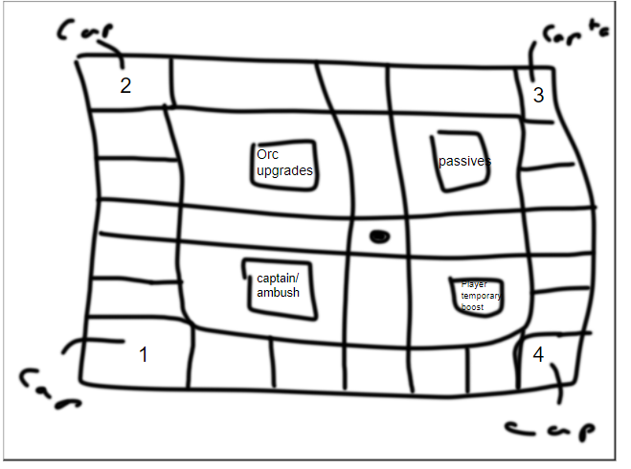If a player loses a battle they are returned to the starting point on the board.

Gameplay

The board is shown on figure 8.1 and displays where the players will play the game. Each player gets their own castle displayed by the numbers on the board 1,2,3,4. The boxes that have text on the display the cards that the players will get after they conquer a territory, to reach the middle of the board.

Figure 8.1 The Board

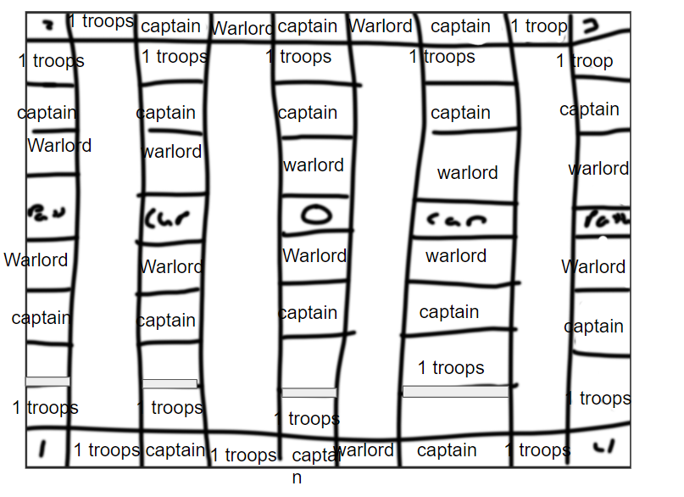

The troop trees are shown on figure 8.2 and displays how the troops can be upgraded to reach the next tier and become stronger. Warlord is the highest and captain is in the middle, while orc is the first tier of troops, they are common but have a great strength in numbers.

Figure 8.2 Troop Trees

Playtesting

Unfortunately, the team did internal playtesting only which showed that the game ended up being quite long, and some of the team members got a bit confused at some points, for example fighting was a bit difficult as when two players fight, the others had to wait for them.

Working in teams

The experience I had working with teams was very educational and I think that I have managed to do my share when working in teams and I have not dragged anyone down. It was interesting how the group members come up with different ideas and in the end all of us decide together which one we should use and implement. Working in teams was very good for me personally as I find it easier to do my tasks and present if I am working with someone else than doing it by myself. I am looking forward to work with teams in the gaming industry as an actual job and I am excited about the things that we can create.

Reflection

In the session I was doing the cards and for the board game and I was coming up with ideas of how to implement certain features from the digital game to the board game that me and my teammates were making. For improvements, I should have talked about more features to implement into the game and how we can make the game easier to understand for the users when we try to present it.

Made by Brennon Franklin, Ben Miller, Spas Spasov, Callum Weaver